Disappearing 4 Patch Blocks
This version uses 5″ squares, so it works great with charm packs!
Select 2 print 5″ squares and 2 background 5″ squares and piece into a four patch block as shown below. Press seams away from the background fabric in each pair and then press to one side after piecing all four together.
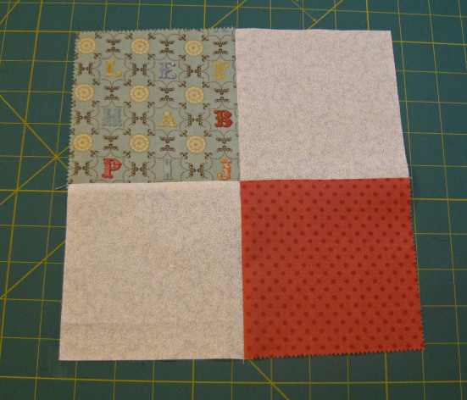
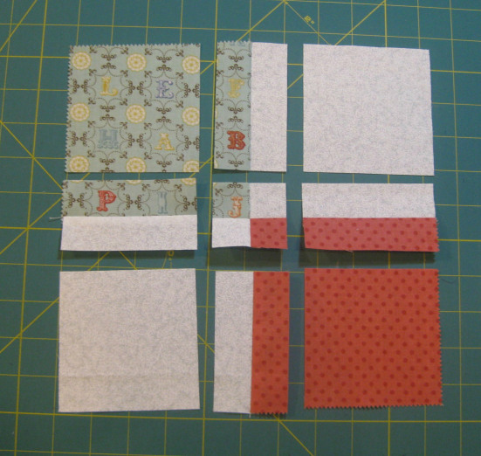
Now, measure 1″ on either side of the center seams and cut. You will then end up with nine separate block pieces as shown to the left.
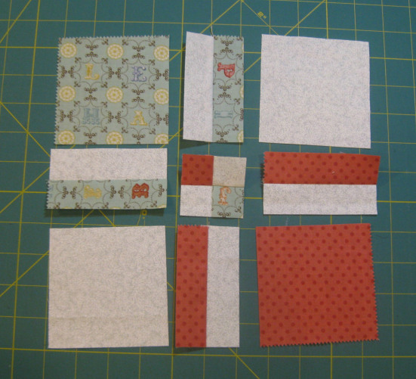
Next, you will swap the top row/center piece with the middle row/left piece. You will also swap the middle row/right piece with the bottom row/center piece. Lastly you will rotate the middle row/center piece 180 degrees. The result will look like the photo below.
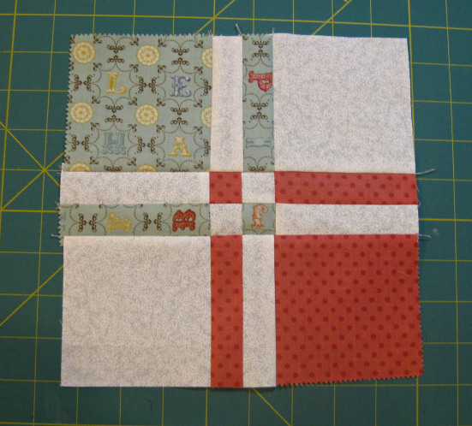 Check out the link for the full tutorial –
Sew the pieces back together and you end up with this cute little block that finishes at 8″!
http://materialgirlquilts.files.wordpress.com/2013/05/cover2.jpg

