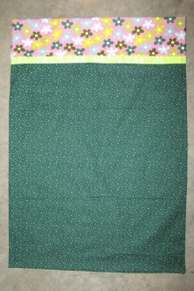
Simple Pillow Cases

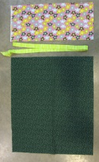
Materials:
26” by width of fabric for Main fabric
10” by width of fabric for Header
2½” by width of fabric – Optional accent

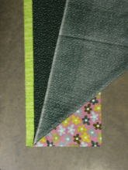
Note: ¼” seam unless otherwise noted. Backstitch at both ends of all seams.
- Fold flange fabric, if using, wrong sides together and press.
- Align one selvage edge of each fabric piece and layer cut edges of fabric as follows: Header, right side up – Main fabric right side up – Flange. Pin. The opposite selvage edge may not align. It will be trimmed later.
- Baste along the cut edge, within the ¼” seam allowance.
- Cut off the selvage along the aligned edge and trim the other selvage edge to the narrowest of the fabric widths, removing all selvages.
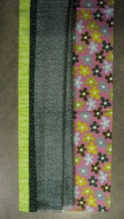
- Accordion fold or roll the main fabric as shown. Fold the raw edge of the header fabric around the folded main fabric to form a tube. Pin cut edges together, being careful not to catch the main pillow fabric. Pin and then sew a ¼” seam.

- Pull the main fabric out thru the open end of the tube and press.
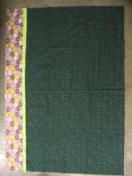

- Sew side seam with a ¼” seam and serge raw edges, or sew a French seam. To make a French seam, sew the side seam with wrong sides together. Trim to 1/8”. Turn wrong side out, press the seam to one side and then press the seam flat, centering the seam at the pressed edge. Sew a ¼” seam, enclosing the raw edges.
- Repeat serged or French seam for bottom hem. Press.
- For an excellent video tutorial: http://www.pinterest.com/pin/98023729359726697/

