Quilting Corners Guild – Community Outreach
Every contribution is valued!
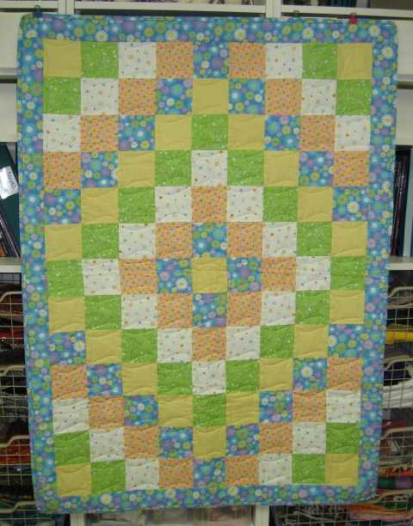
- Quilts of Comfort – 509 donated as of July 2017
for My Sister’s Place for People in Transition
- typically baby to throw size, but all sizes accepted
- variety required – baby, toddler, youth, mom – girls and boys
- create your own
- take home a kit for a top or a kit to be quilted
- take home a quilt ready for binding – by hand or machine
- return everything to Senora for next steps & distribution
- presented during Christmas in July and our December meeting

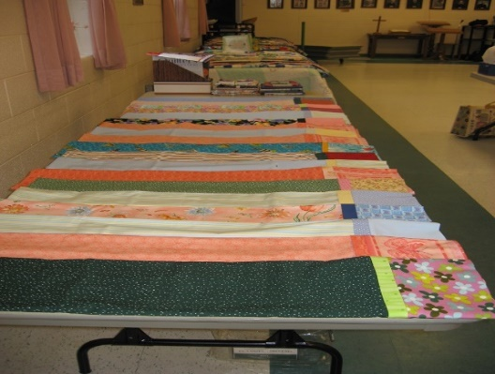
- Pillowcases – 174 donated as of April 2016
for Matthews House Hospice
- create your own – body WOF x 26”, header WOF x 10”, trim WOF x 2 ½” – finished seams
- take home a kit
- full instructions under ‘Projects’ on guild website
- return to Senora for archive and packing
- presented during Christmas in July and our December meeting

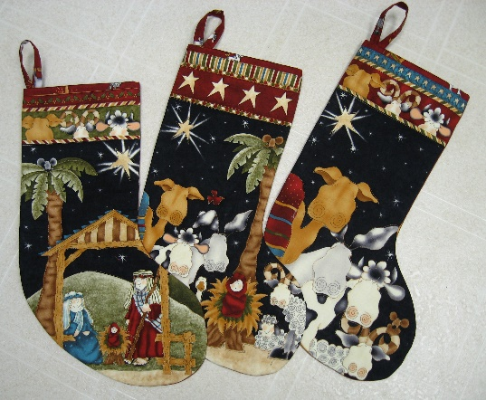
- Stockings & Santa Sacks – 369 –December 2016
for My Sister’s Place for People in Transition
- create festive stockings for the Christmas celebrations at MSP
- stockings are about 20” in length –pattern available
- Santa Sacks are basically pillowcases with a drawstring, for youth – any fabric colour combos
- collected by Senora during the Fall and presented at our December meeting

- Sit’n’ Sew
- generally we have 2 sewing Saturdays – 1 in the Fall & 1 in the Spring to work on UFOs, demos or Quilts of Comfort – kits provided, snacks and tea/coffee provided, bring your own lunch
- join us for a dedicated day of sewing and socializing!

- Days for Girls – 176 donated as of October 2016
- Drawstring bags, toiletries & undergarments to support girls in 3rd world countries during their menstrual cycle.
- Fabric Donations
- Most of the fabric for our outreach work has been donated – if you have some contributions of quilt worthy fabric – large or small, let us know – every bit is used and appreciated!
- Batting – monthly raffle money goes toward the purchase of a roll of batting – but donations of batting are all put to good use!

- QUILT-O for the Good Shepherd Foodbank
- Money collected from playing QUILT-O at our December meeting supports the foodbank

- Slab Blocks
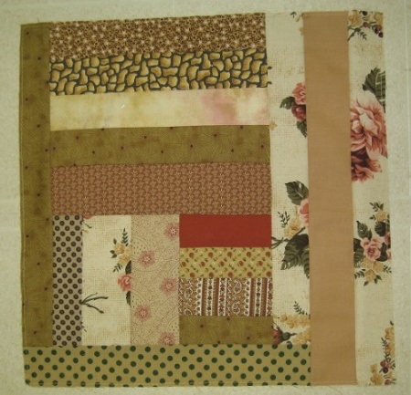
- A Slab Block is a block made from random strips in one colour until it is 14 ½ x 14 ½”
- If you would like a smaller project to work on, use up scraps – or we can provide lots of strips – and create a block or two or three…
- Senora will collect the blocks and when there are 12 – they will be assembled to create a lap quilt

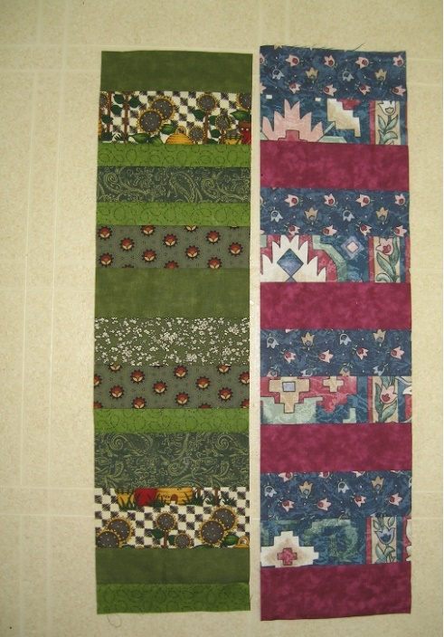
- Stacking Coins
- Strips sewn together in ‘stacks’ 6 x 24” in one colour or from a collection
- Another quick project from scrappy strips
- Senora will collect the ‘Stacking Coins’ strips and when there are 12 – they will be assembled to create a scrappy lap quilt 2 rows by six strips with a solid colour sashing thru the centre and around each strip to join and form a border
- OR create stacks 6 by 50 (give or take) – 6 strips can then be joined as vertical strips with sashings and borders

- Cat Pillows – monthly donations to the OSPCA
- Create a basic pillow case 12” x 15” and stuff with scraps of batting and fabric (no sharp bits)
- Zig Zag closed and bring to guild
- Pillows will be donated to the animal shelter

Questions??? See Senora or email skbaldry@gmail.com
Thanks! Revised July 18, 2017

