**Stitching Among Friends – 2017 - Quilts**

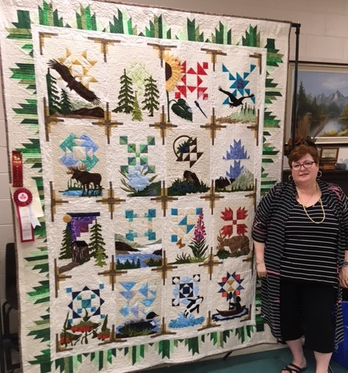

**Overall Viewer’s Choice – CQA Rosette Winner**

**1**st - Judy Cotter – *Northern Wilderness*

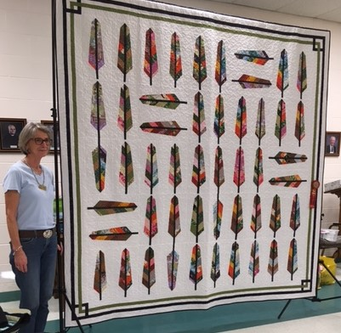

**1**st – Maureen Banks – *Not Your Grandmother’s Feather Quilt*

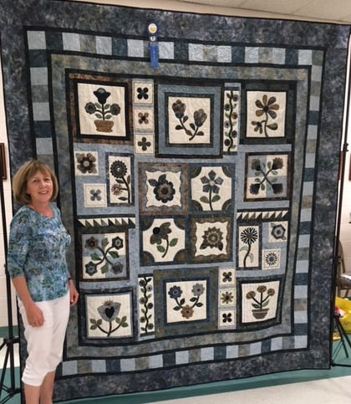 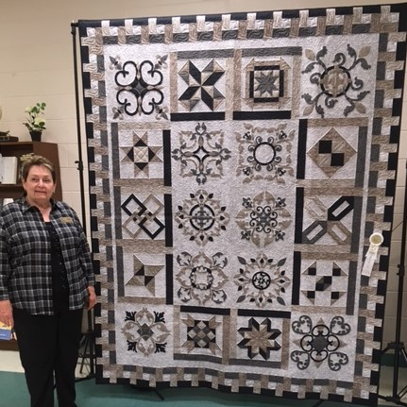

**3**rd – Arlene Gibson – *Applique Interrupted*

**2**nd – Peggy Feehely –

*Quilter’s Garden*