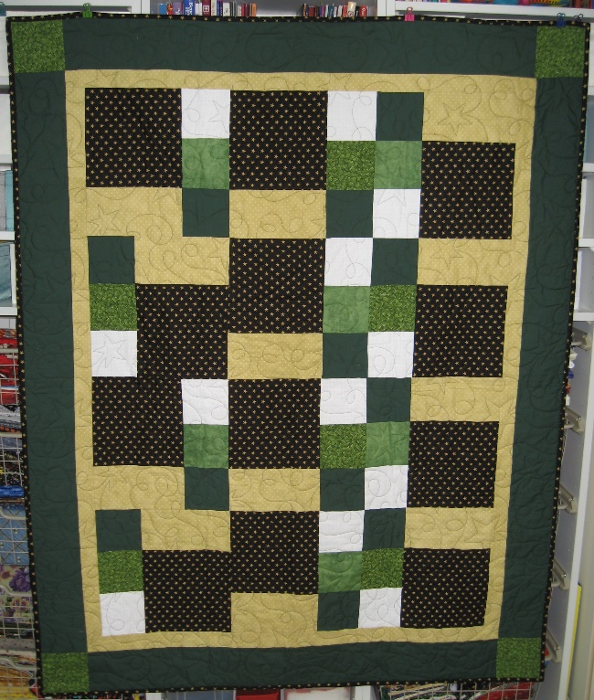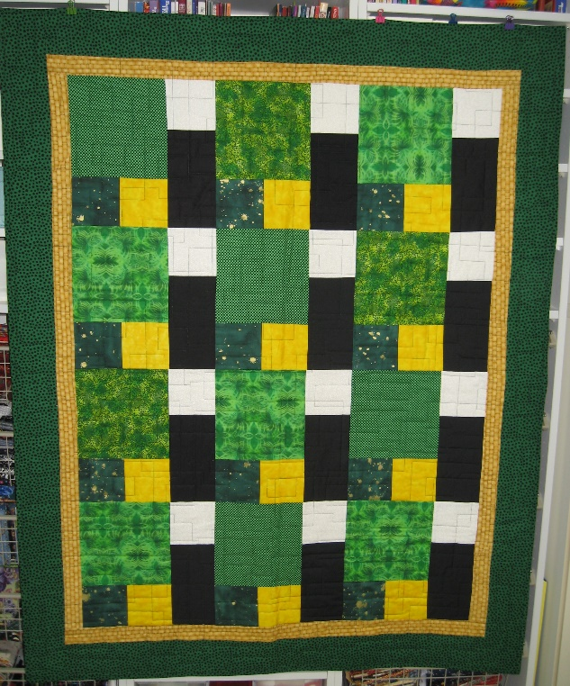
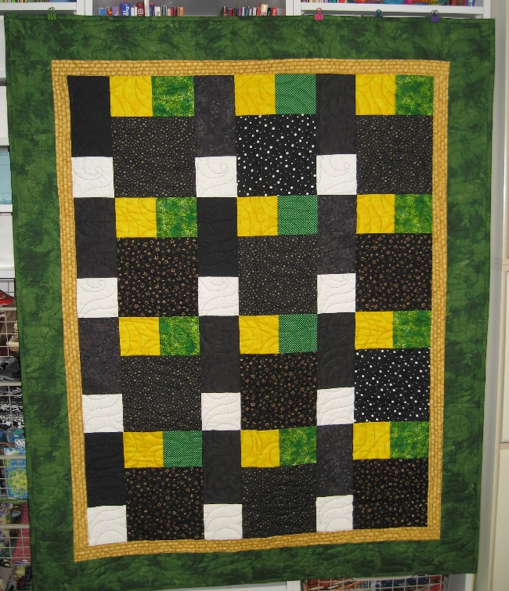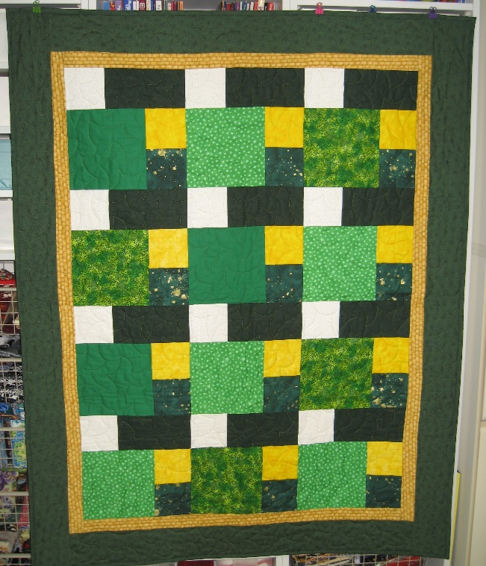

Quilts of Comfort for Humboldt created by members of Quilting Corners Guild, May 2018. Sent to Humboldt along with ‘A Quilters Heart’ poem composed by member Jan Pettit.

