- Cut 1 strip 6” x WoF and
1 strip 9” x WoF from flannel.
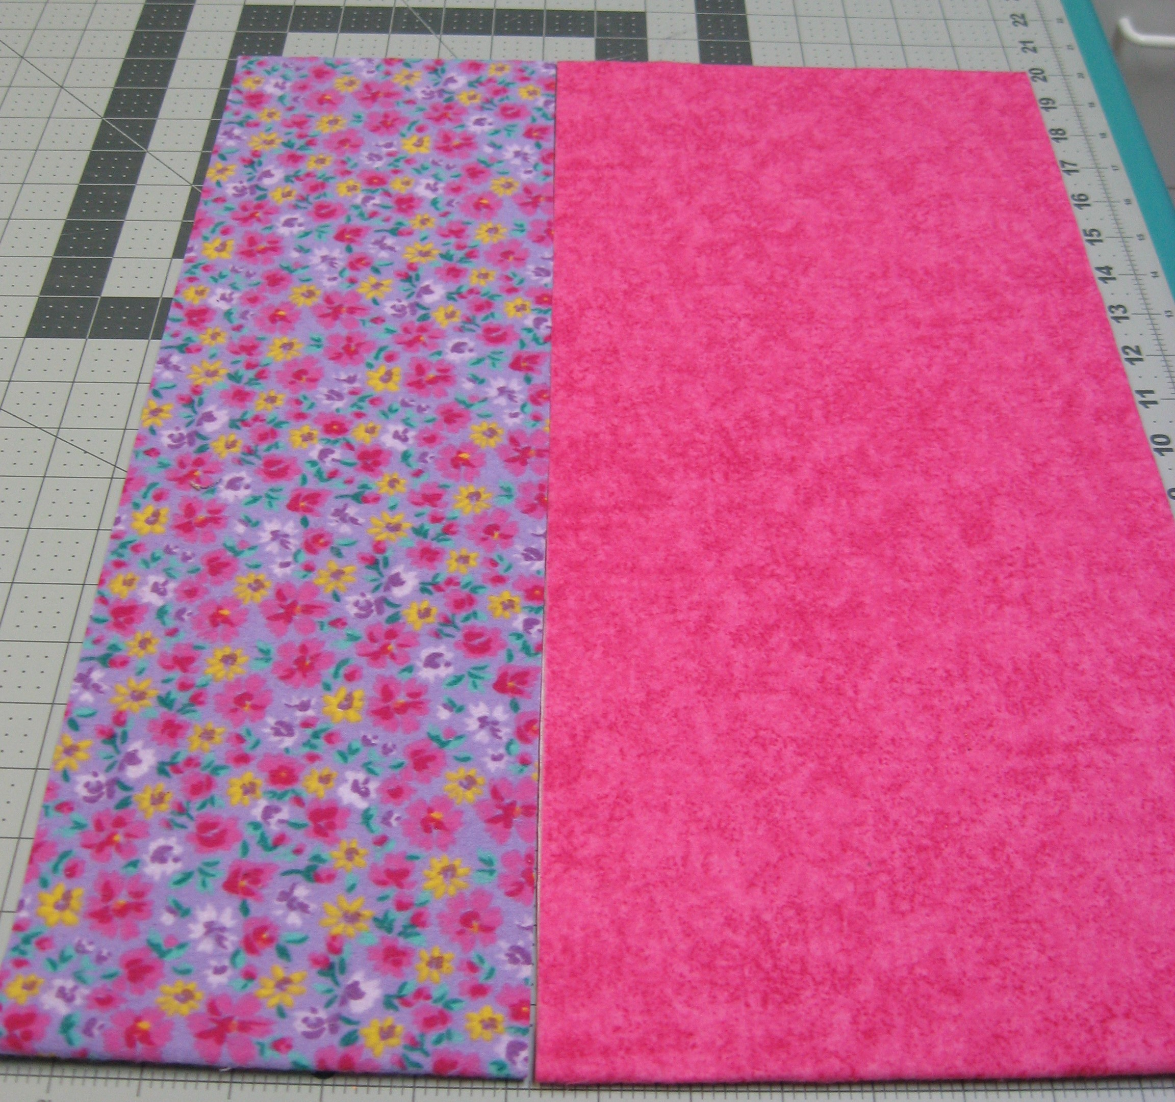

- Serge long edges of 6” strip (5 ¾” trimmed). Lay 9” strip on cutting mat, wrong side up. Centre serged 6” strip, wrong side down, on 9” strip. There will be 1 ½” on either side from edge to narrow strip. Pin and stitch together along serged edges with domestic machine (use the centre of your serged stitching as a guide).
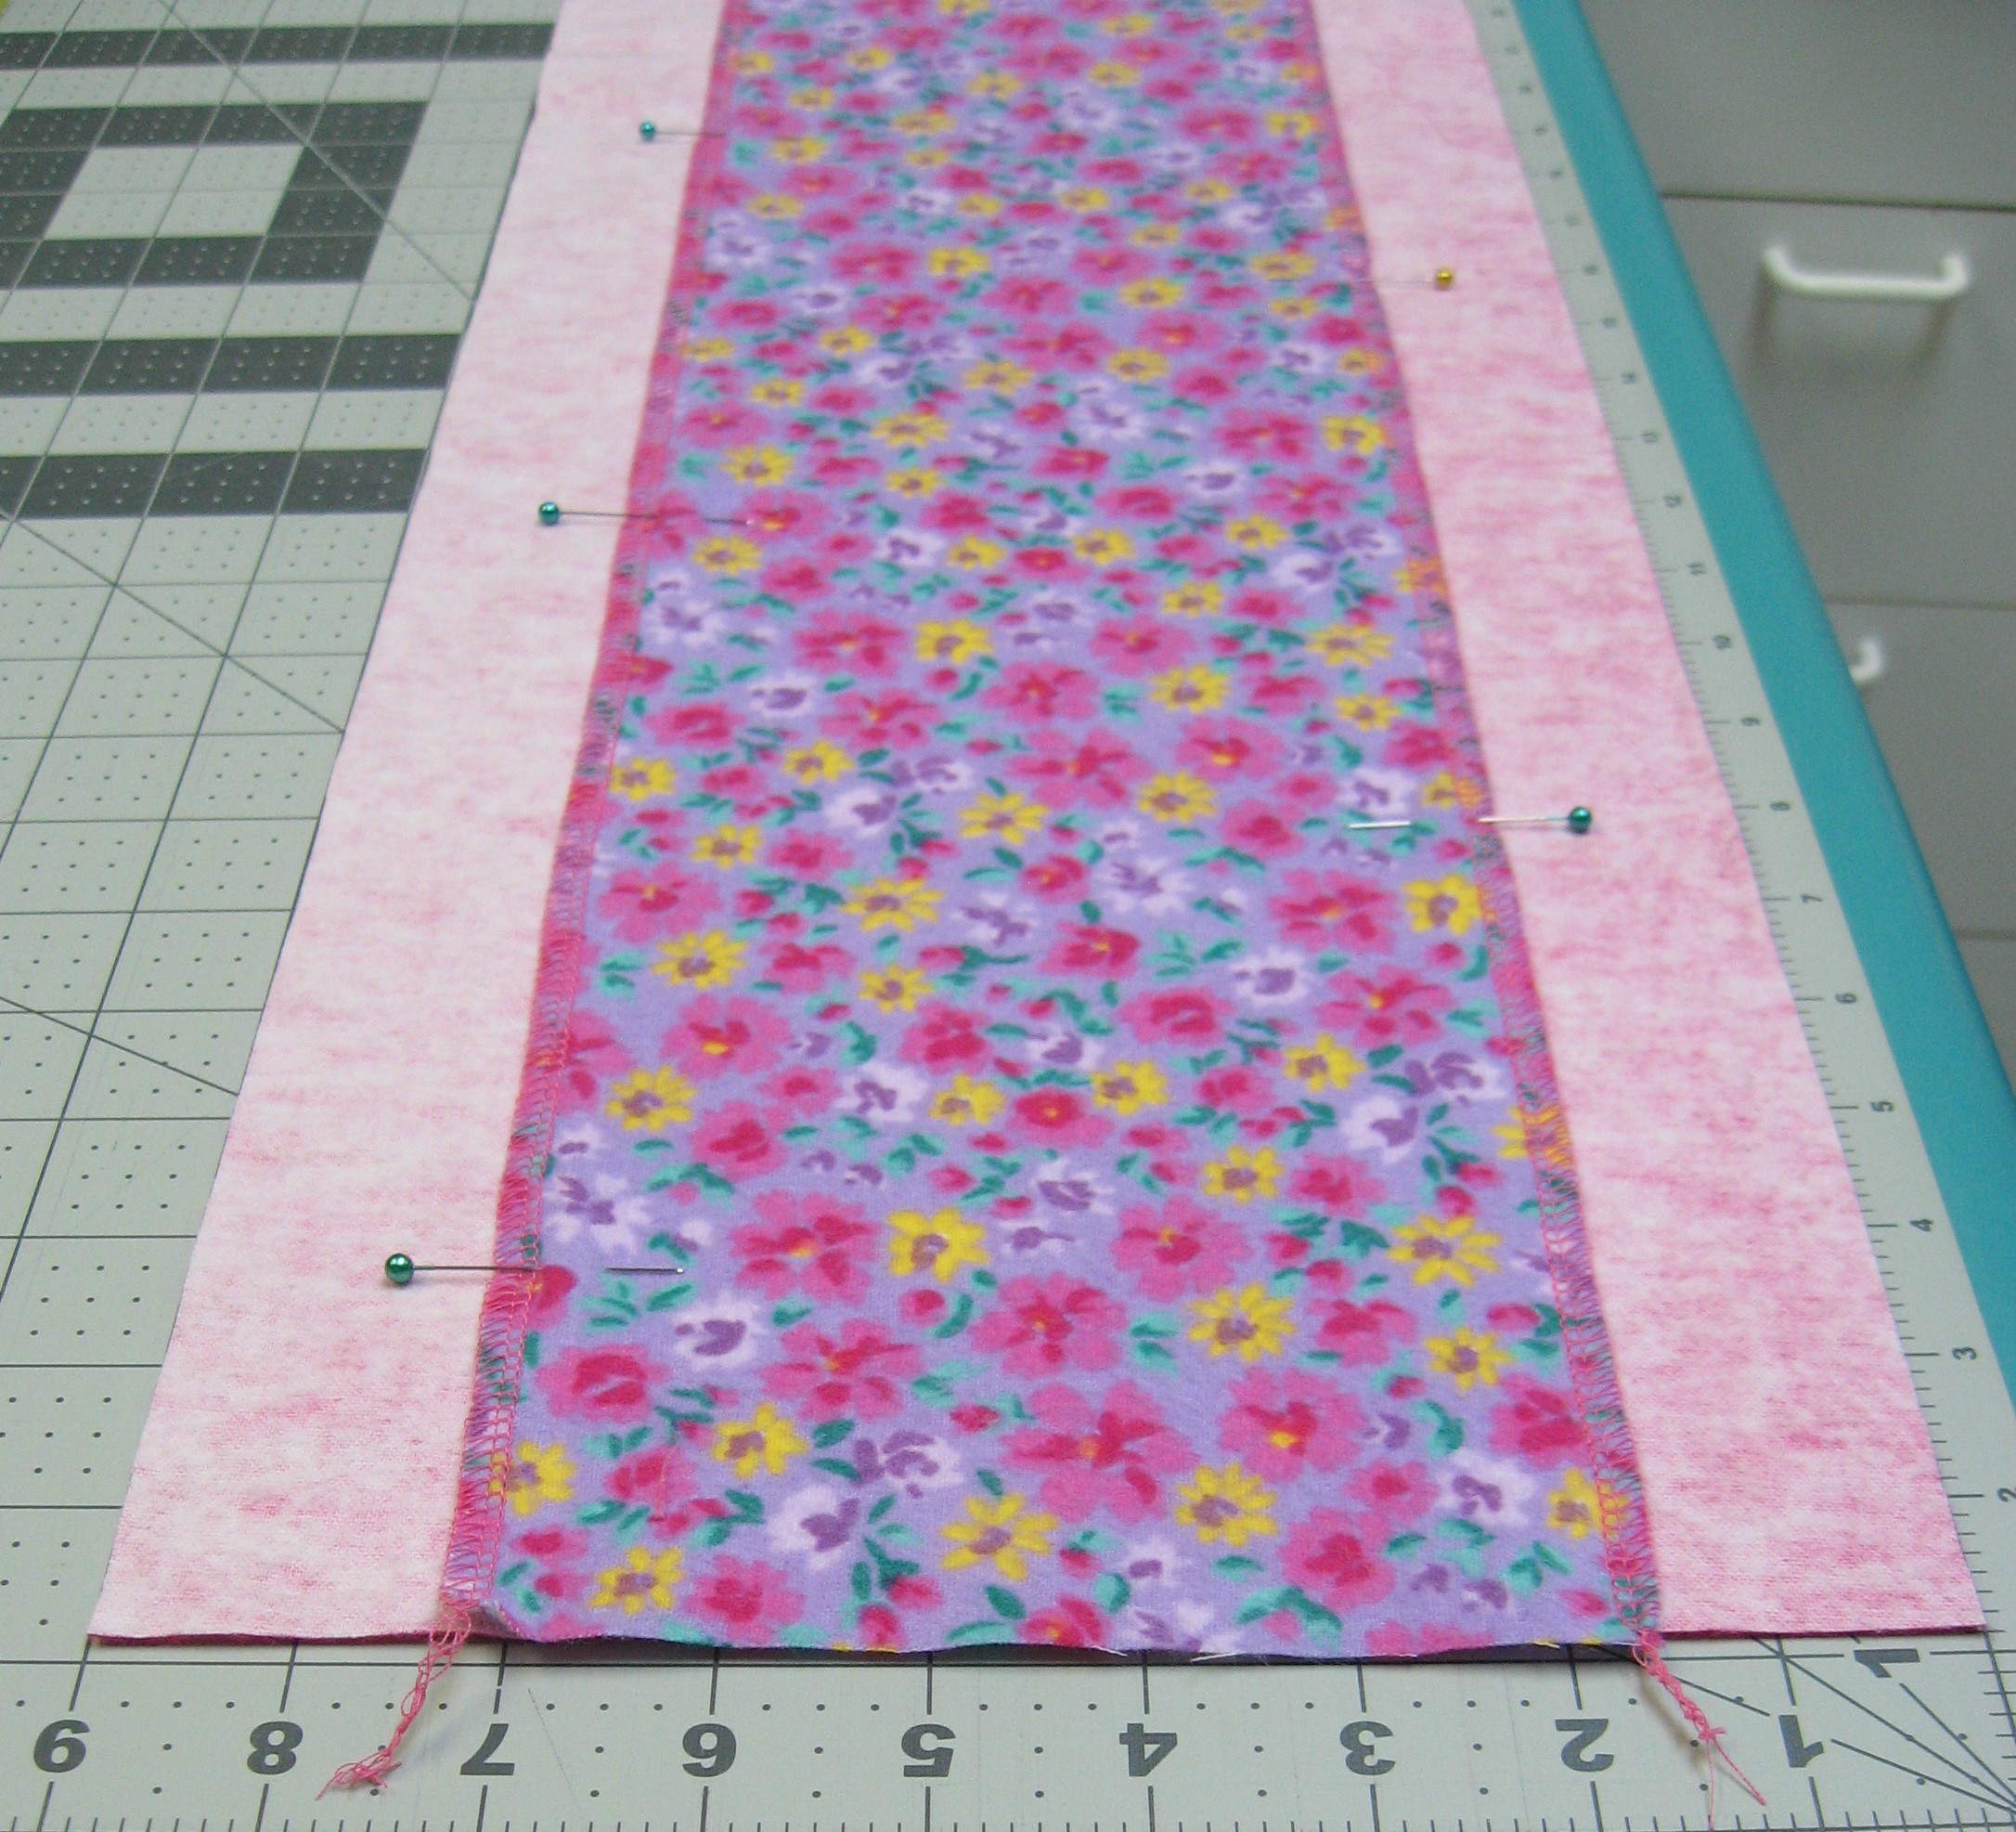

- Lay sewn strip on cutting mat and sub-cut in 9” blocks.
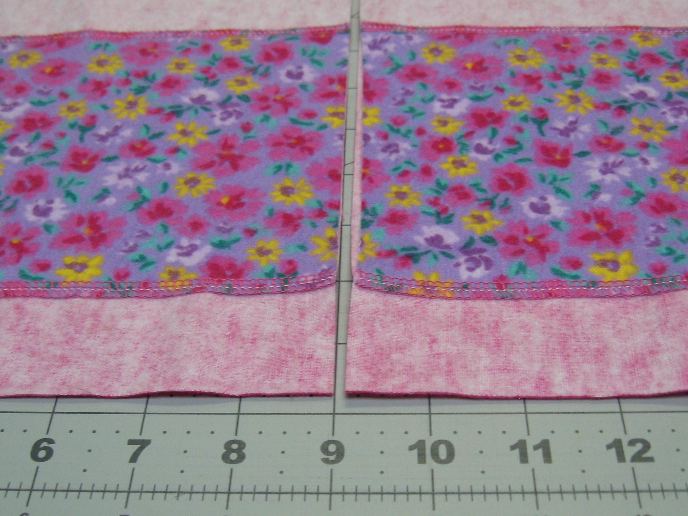

- Trim corners to round them using a 3 ½” circle template, petal template OR VersaTool (Handi Quilter).
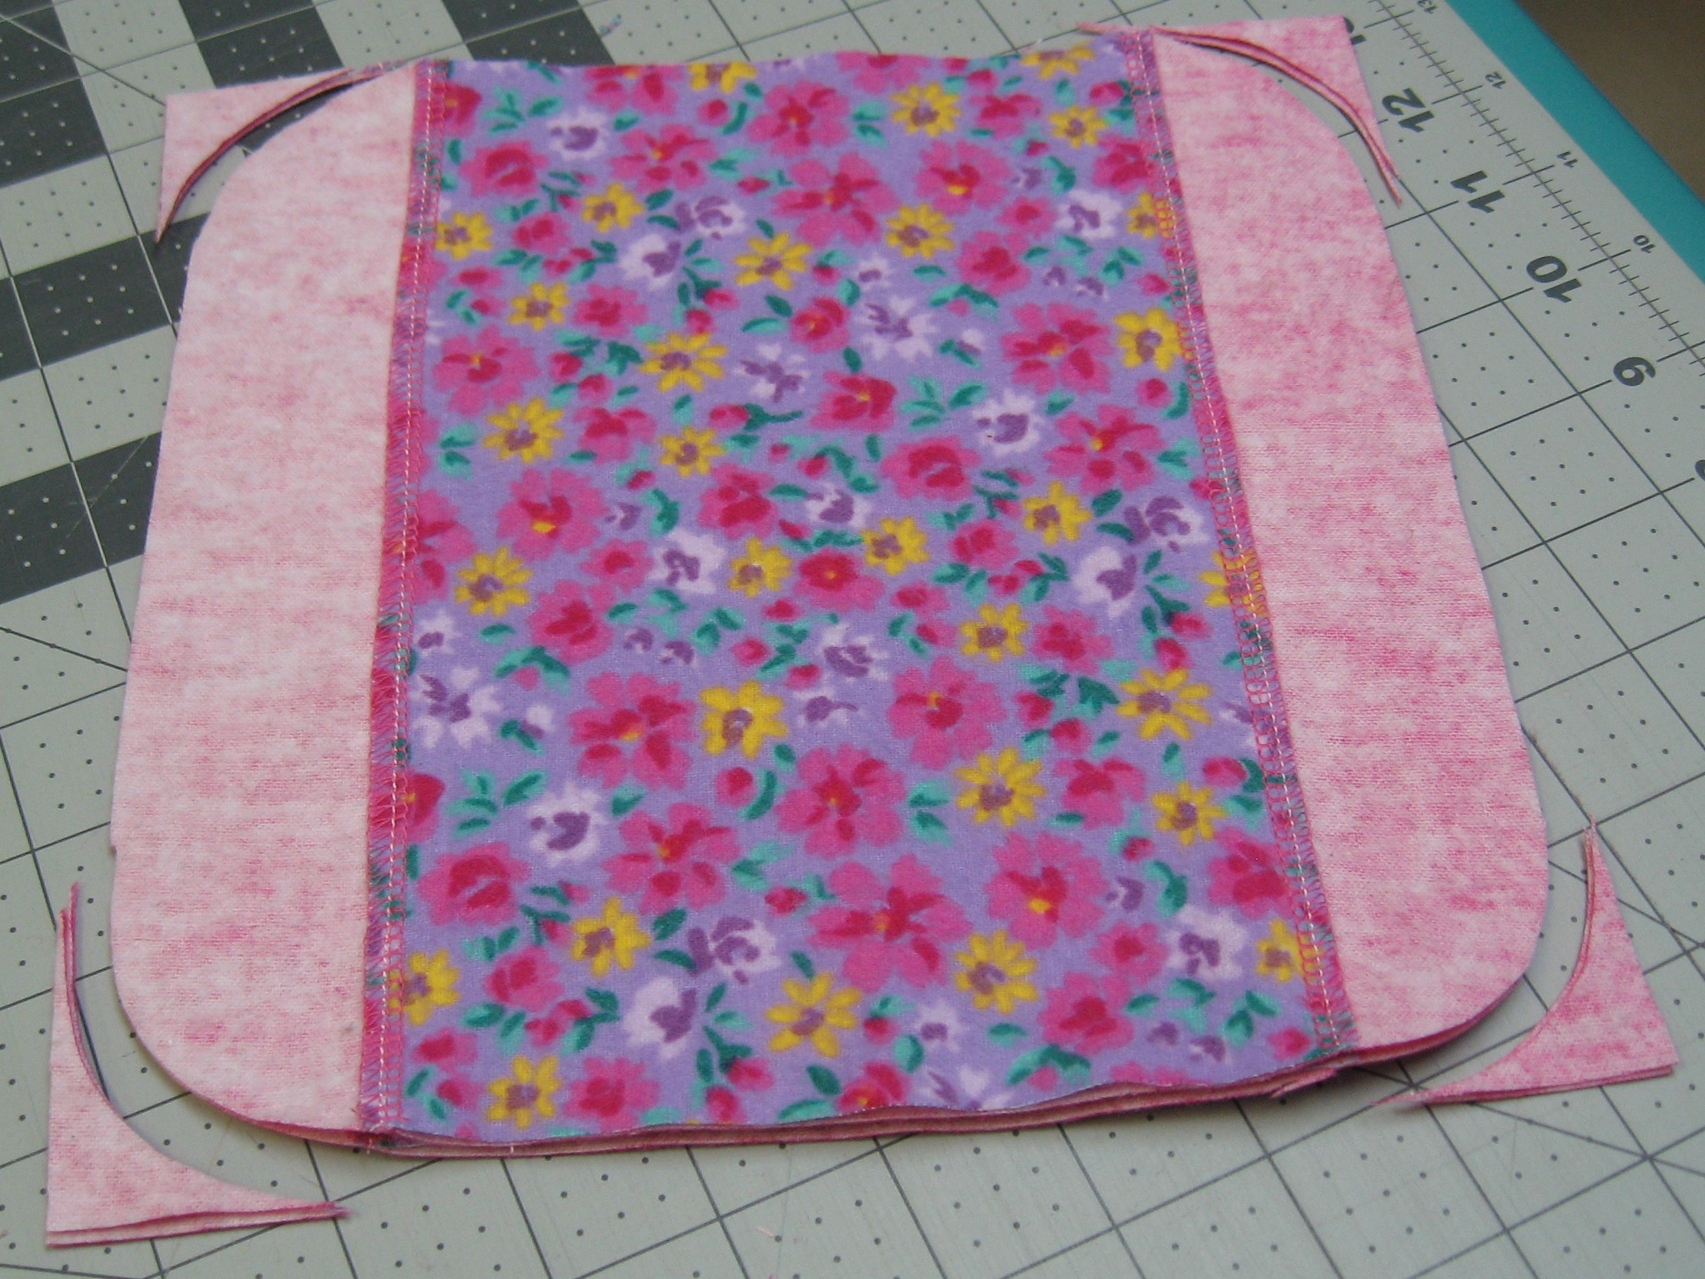

- Serge around each block, carefully trimming and turning – begin 1 inch before a corner through both layers and end by serging over the start and running off the corner. There should be no loose loops or threads.
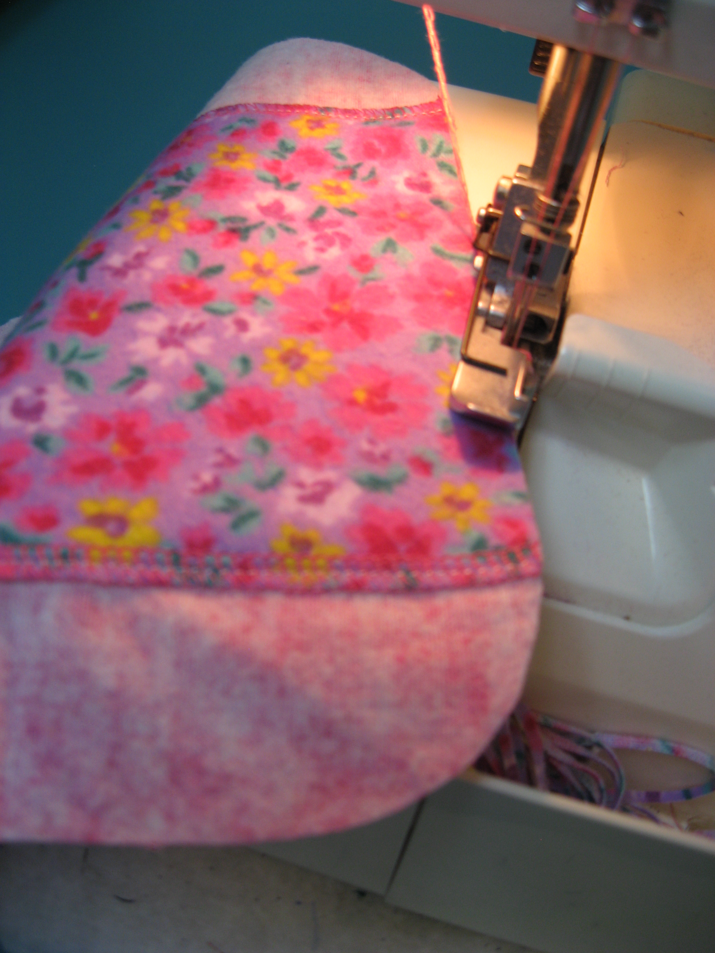
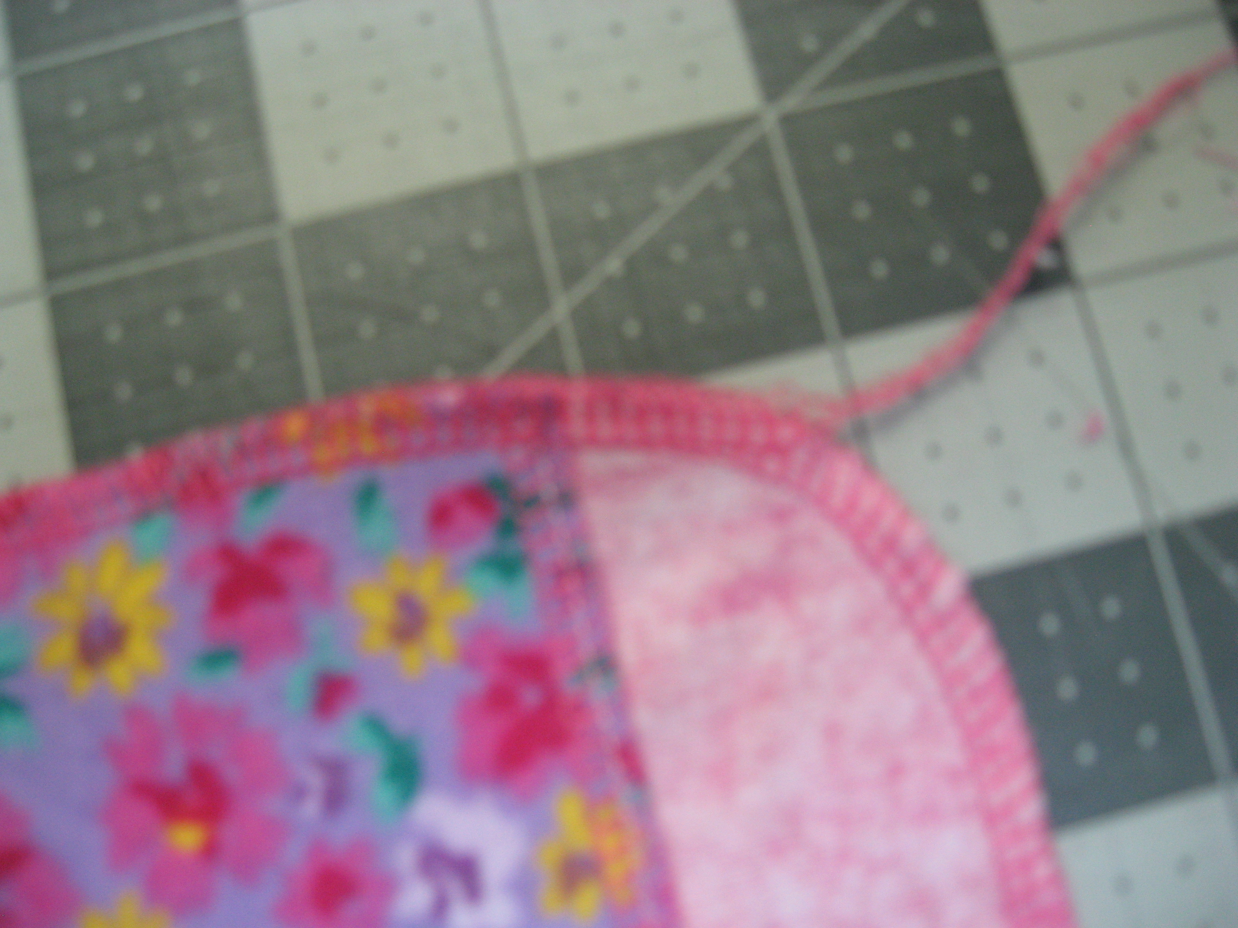

- Completed liner must be 8 ½” – 8 ¾” square.
