Quilting Corners Guild – Community Outreach
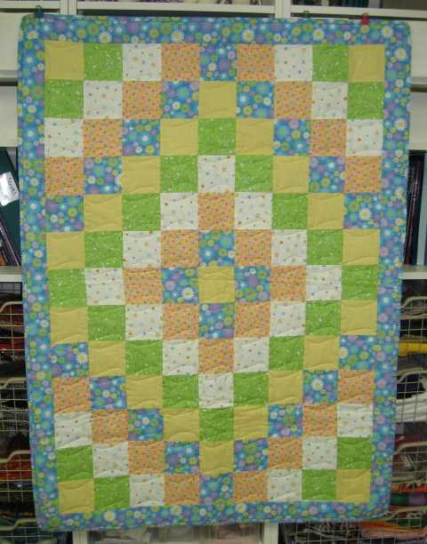
Every contribution is valued!
- Quilts of Comfort – 617 donated as of July 2018
for My Sister’s Place for People in Transition
- typically baby to throw size, but all sizes accepted
- variety required – baby, toddler, youth, mom – girls and boys
- create your own or take home a kit for a top assembly, quilting or binding
- we will be working on 10 single size quilts for the residence
- return everything to Senora for next steps & distribution
- presented during Christmas in July and December meetings

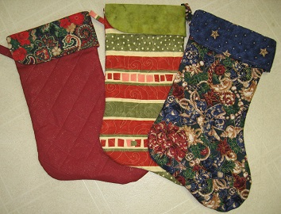
- Stockings & Santa Sacks – 456 –December 2017
for My Sister’s Place for People in Transition
- create festive stockings for the Christmas celebrations at MSP
- stockings are about 20” in length –pattern available
- Santa Sacks are basically pillowcases with a drawstring, for youth – any fabric colour combos
- presented at our December meeting

- Sit’n’ Sew
- generally we have 2 - 3 sewing Saturdays – to work on UFOs, demos or Quilts of Comfort – kits provided, snacks and tea/coffee provided, bring your own lunch
- join us for a dedicated day of sewing and socializing!
- Next Sit n Sew is August 18 in Baxter

- Days for Girls – 400 bags, 207 Liners & 30+ lbs of toiletries/panties donated as of May 2018
- Drawstring bags, toiletries, undergarments, large Ziploc baggies & thread to support girls in 3rd world countries during their menstrual cycle.

- QUILT-O for the Good Shepherd Foodbank
- Money collected from playing QUILT-O at our December & July meetings to support the local foodbank.

- Other Items Received for My Sister’s Place for People in Transition
- Fleece Blankets & Receiving Blankets – 14
- Hats, Mittens & Scarves - 30
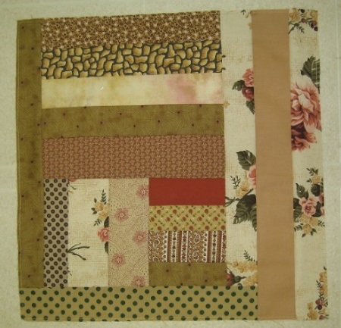
- Slab Blocks
- A Slab Block is a block made from random strips in one colour until it is 14 ½ x 14 ½”
- If you would like a smaller project to work on, use up scraps – or we can provide lots of strips – and you can create a block or two or three…
- Senora will collect the blocks and when there are 12 – they will be assembled to create a lap quilt.

- Stacking Coins
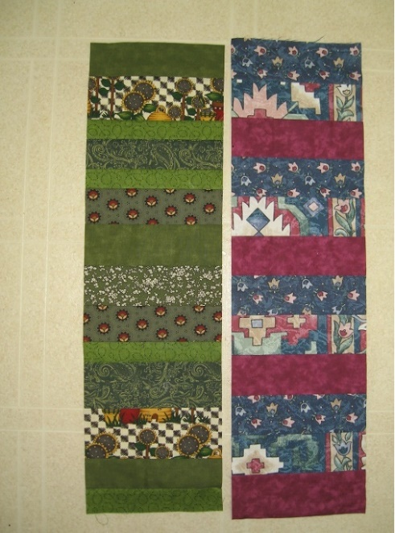
- Strips sewn together in ‘stacks’ 6” x 24” in one colour or from a collection of fabrics
- Another quick project from scrappy strips
- Senora will collect the ‘Stacking Coins’ strips and when there are 12 – they will be assembled to create a scrappy lap quilt 2 rows by six strips with a solid colour sashing thru the centre and around each strip to join and form a border
- OR create stacks 6 by 50 (give or take) – 6 strips can then be joined as vertical strips with sashings and borders

- Cat Pillows – monthly donations to the OSPCA
- Create a basic pillow case 15” x 20” and stuff with scraps of batting and fabric (no sharp bits)
- Zig Zag closed and bring to guild
- Pillows will be donated to the animal shelter

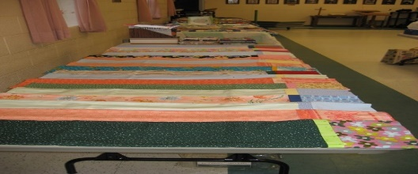
- Pillowcases – 174 donated as of April 2016 for Matthews House
- 58 donated to MSP December 2017
- create your own – body WOF x 26”, header WOF x 10”, trim WOF x 2 ½” – finished seams

- More Quilts of Comfort for Matthews House Hospice
- 10 bed quilts were donated on July 10, 2018 for the opening of the new facility on July 12.
- A request was made for 10 large lap size quilts for the daybeds in each resident room.

- Fabric Donations
- Most of the fabric for our outreach work has been donated – if you have some contributions of quilt worthy fabric – large or small, let us know – every bit is used and appreciated!
- Batting – monthly raffle money goes toward the purchase of a roll of batting – but donations of batting are all put to good use!

Questions??? See Senora or email skbaldry@gmail.com
Thanks! Revised July 17, 2018

