Two Colour Binding - Hand Finished

- Cut 1” strip to match front of quilt in length required
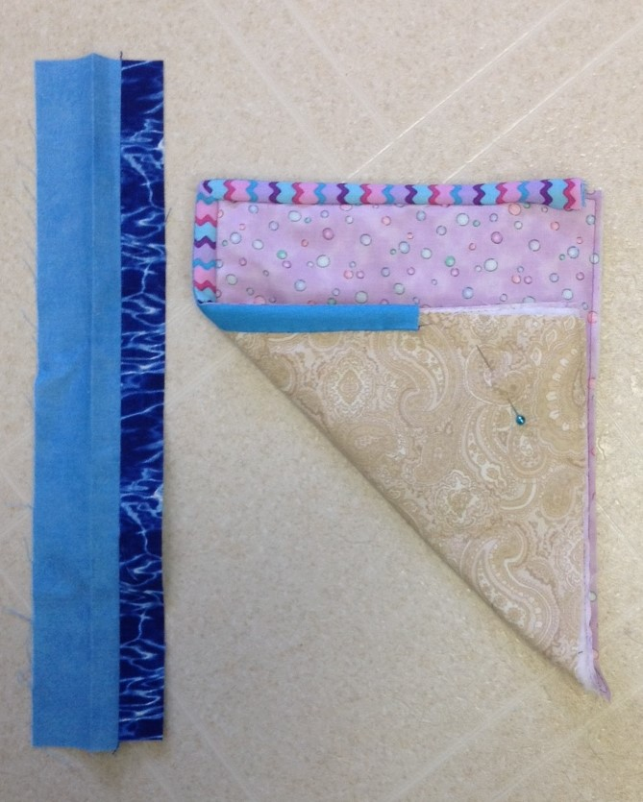
- Cut 2” strip to match back of quilt in length required
- Sew strips together lengthwise using ¼” seam, offset
joins to reduce bulk
- Press seam open, preferably
- Fold strip in half, lining up edges, and press
- Pin on quilt top, with top fabric right side to quilt top
- Stitch by machine, join ends
- Fold over and stitch in place by hand sewing

Two Colour Binding - Machine Finished

- Cut 2” strip to match front of quilt in length required
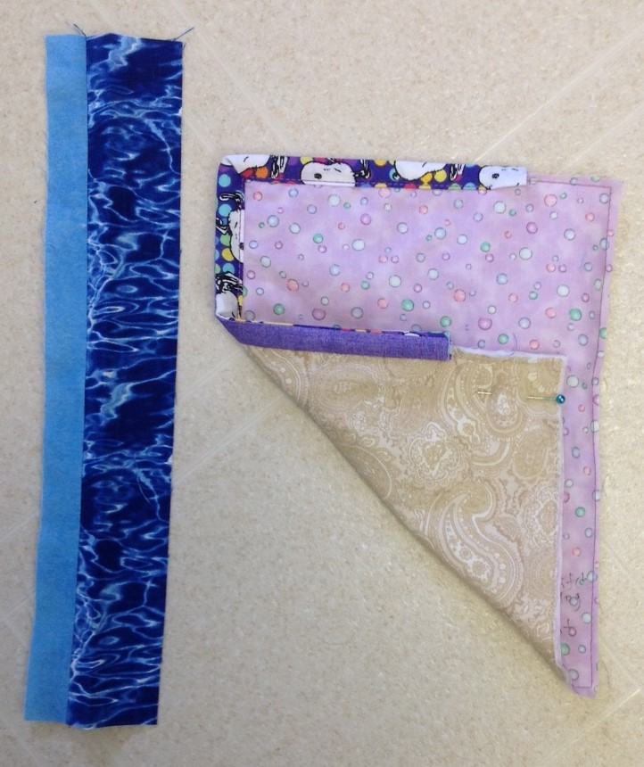
- Cut 1” strip to match back of quilt in length required
- Sew strips together lengthwise using ¼” seam, offset
joins to reduce bulk
- Press seam open, preferably
- Fold strip in half, lining up edges, and press
- Pin on quilt back, with back fabric right side to quilt back
- Stitch by machine, join ends
- Fold over and stitch in place by machine sewing

SK Baldry March 2019

