Split 9 Patch – Chain Link Variation – 51 x 64 Finished
Requirements for Top
- 10 (10”) Blocks – leftover layer cakes or 30” fabric
- 50 (5”) Print squares – leftover charms or 30” fabric
- 40 (5”) Solid (or Tone on Tone) squares – 25” fabric
- 5 (2 ½” ) Solid Strips subcut – 20 x 10” – 12 ½” fabric
- 8 (2 ½ ”) Solid Strips subcut – 20 x 14” – 20” fabric
- Total Solid fabric = 58” or 1.5m
- Binding – 6 (2 ½”) strips
Split 9 Patch
Solid | Print | Solid
Print | Print | Print
Solid | Print | Solid

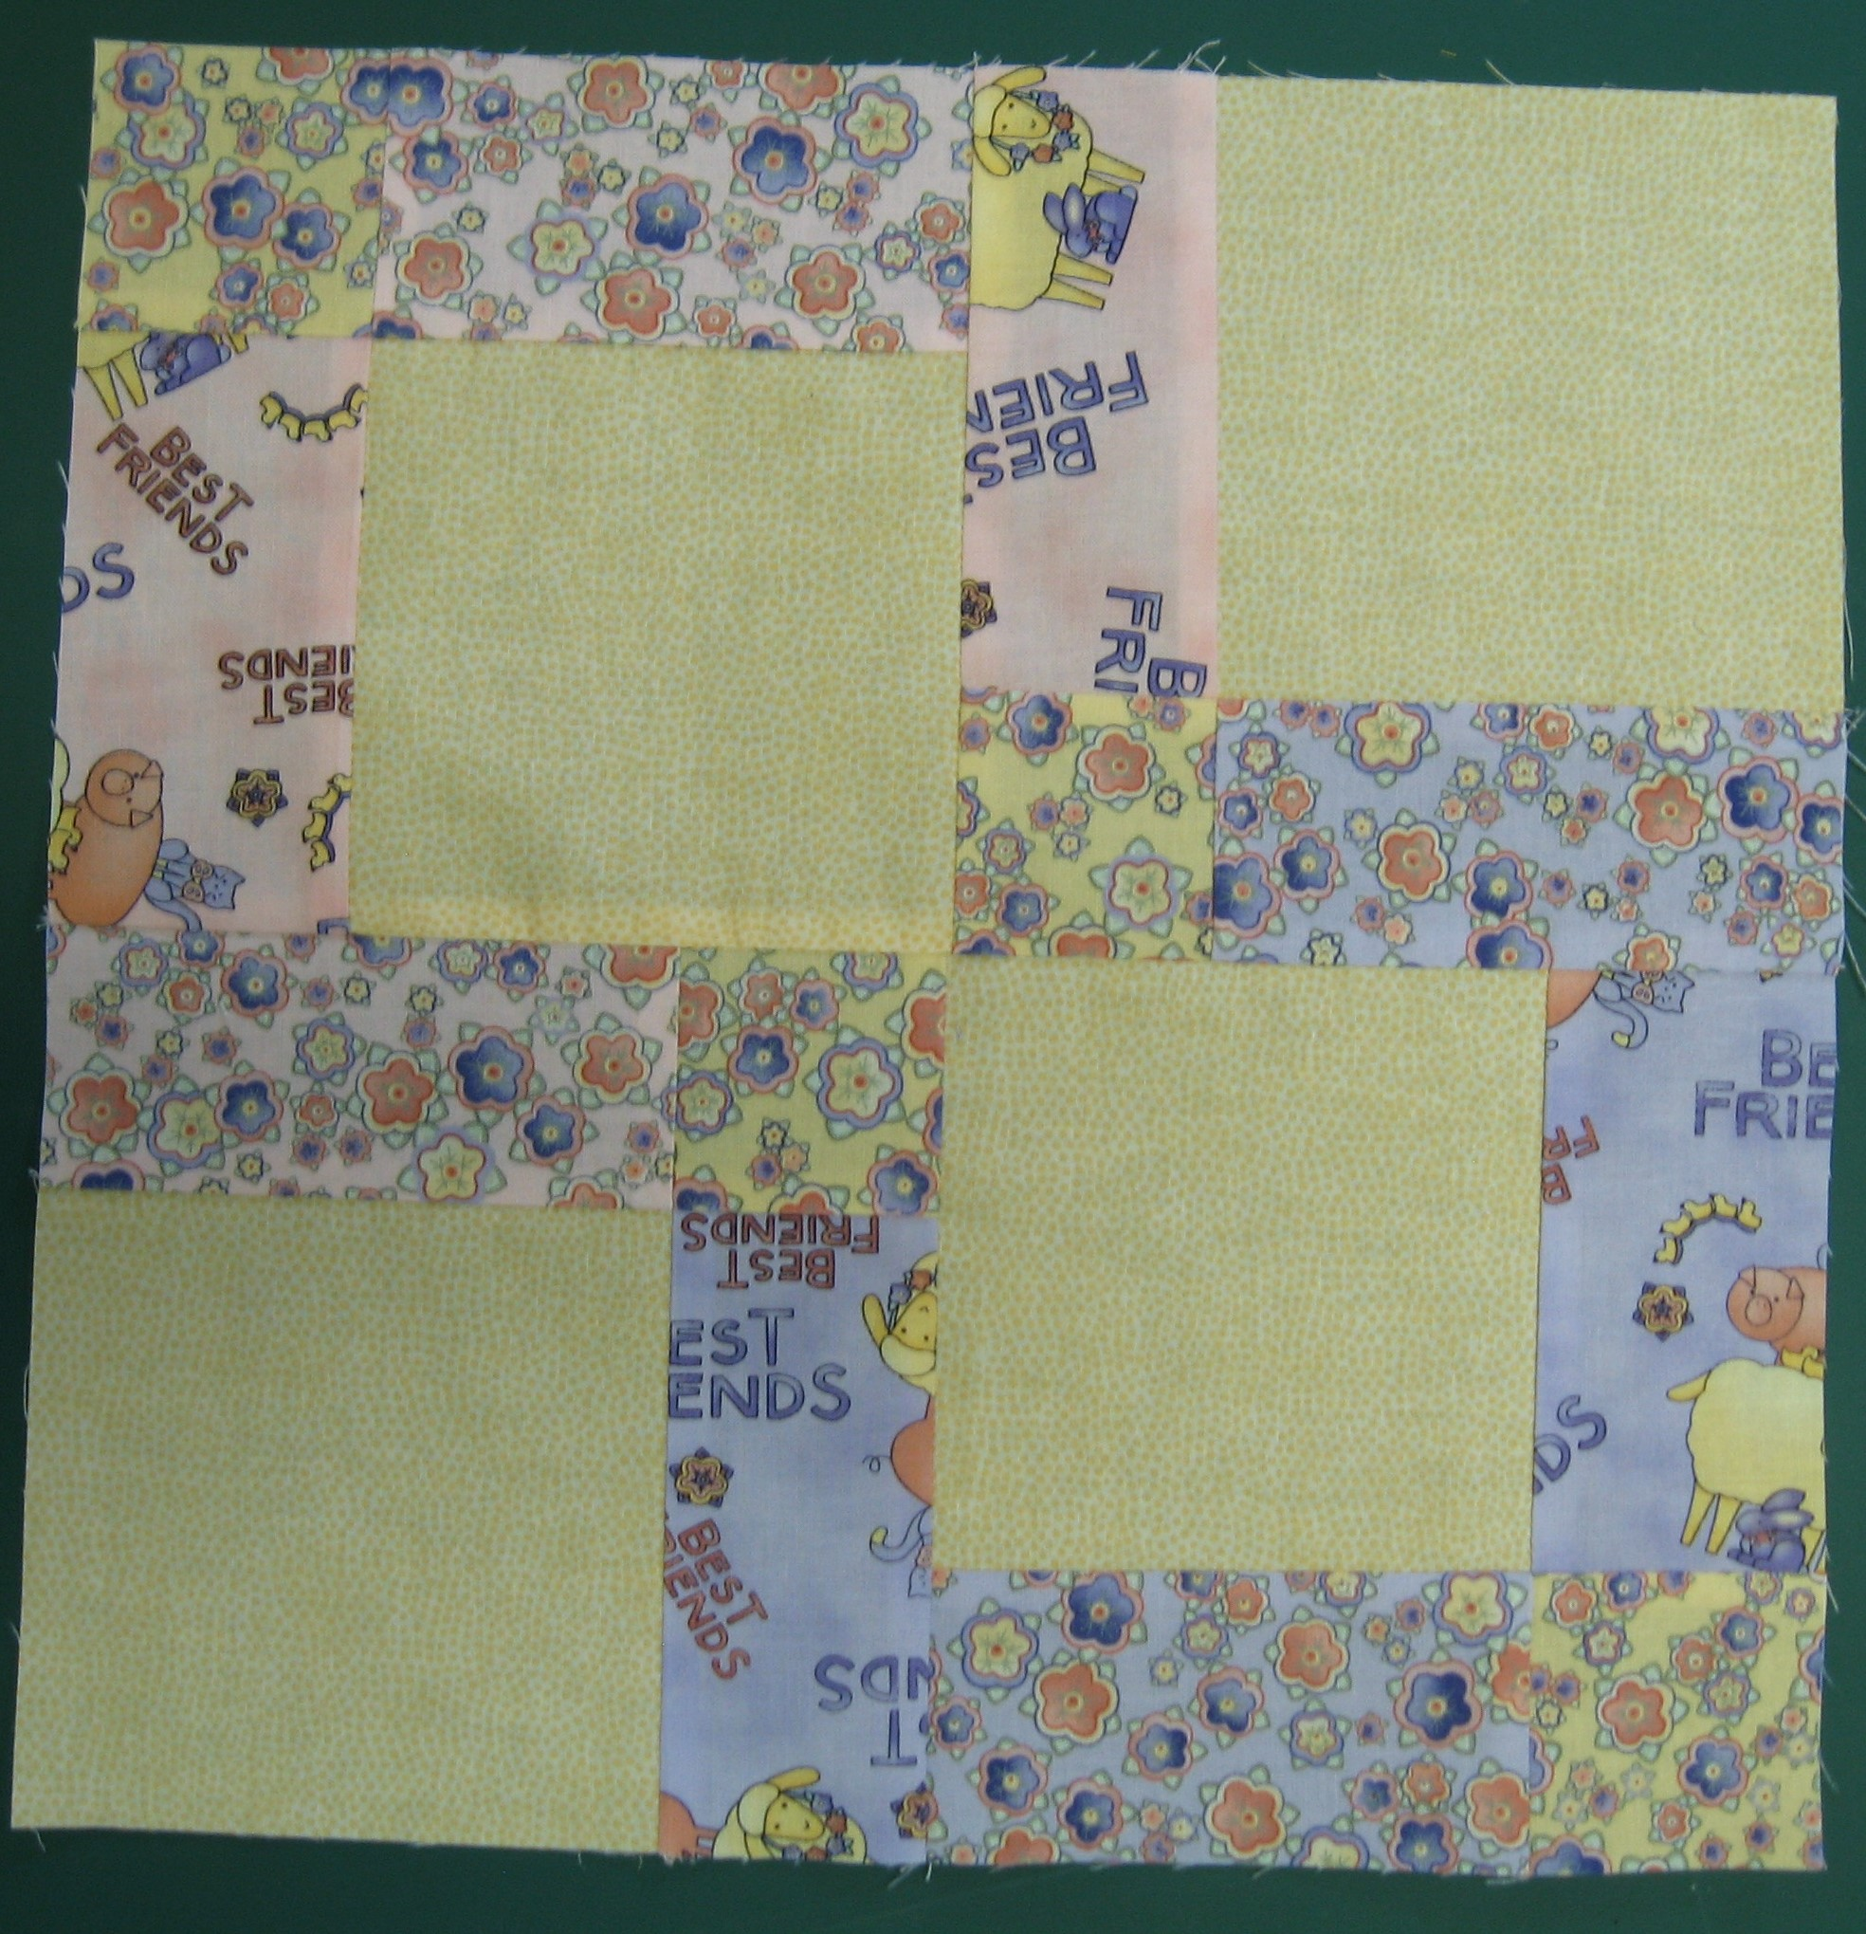
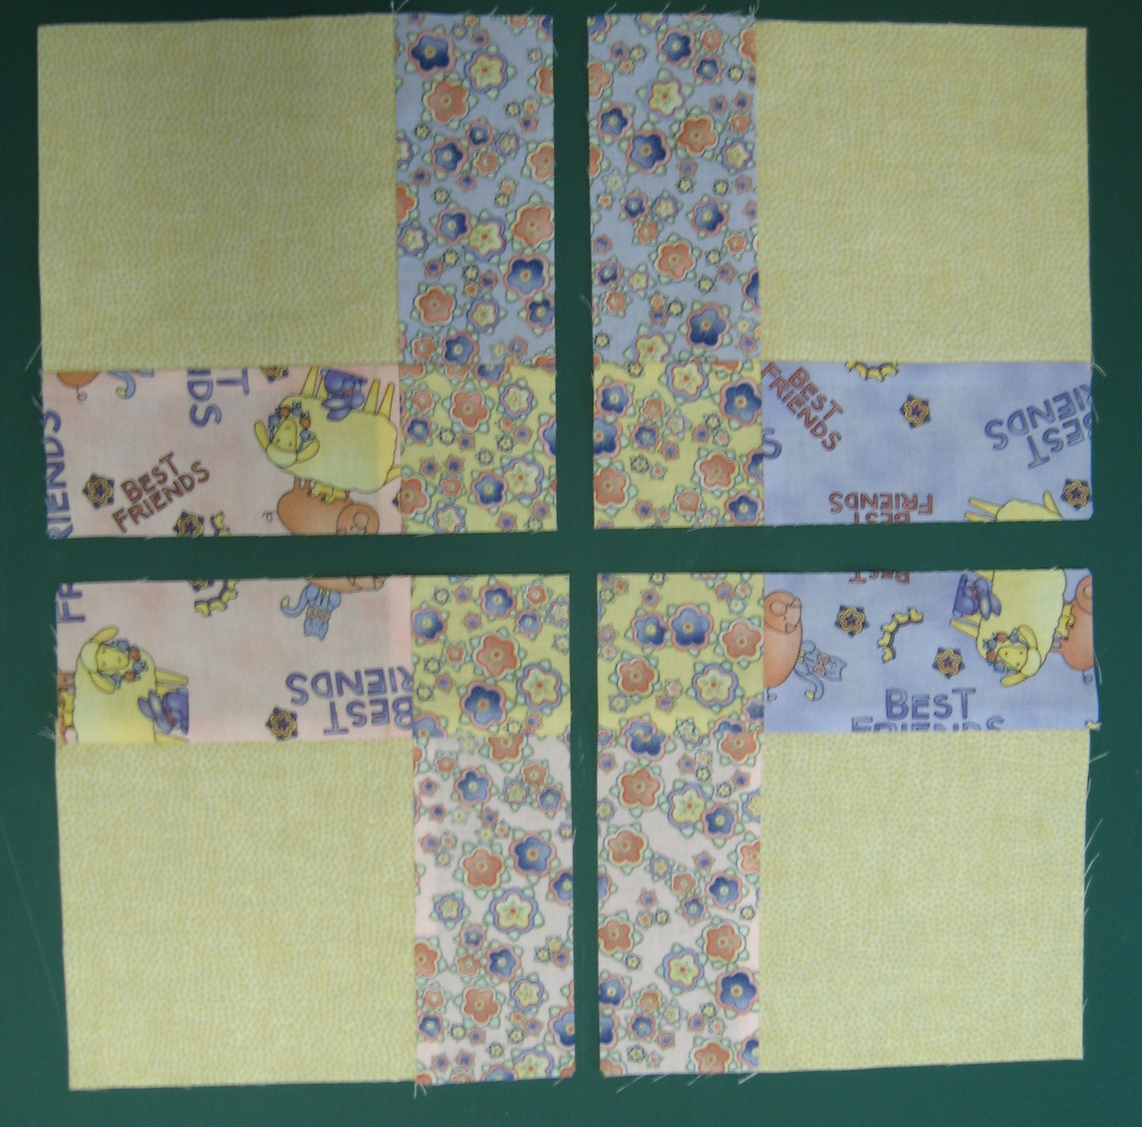
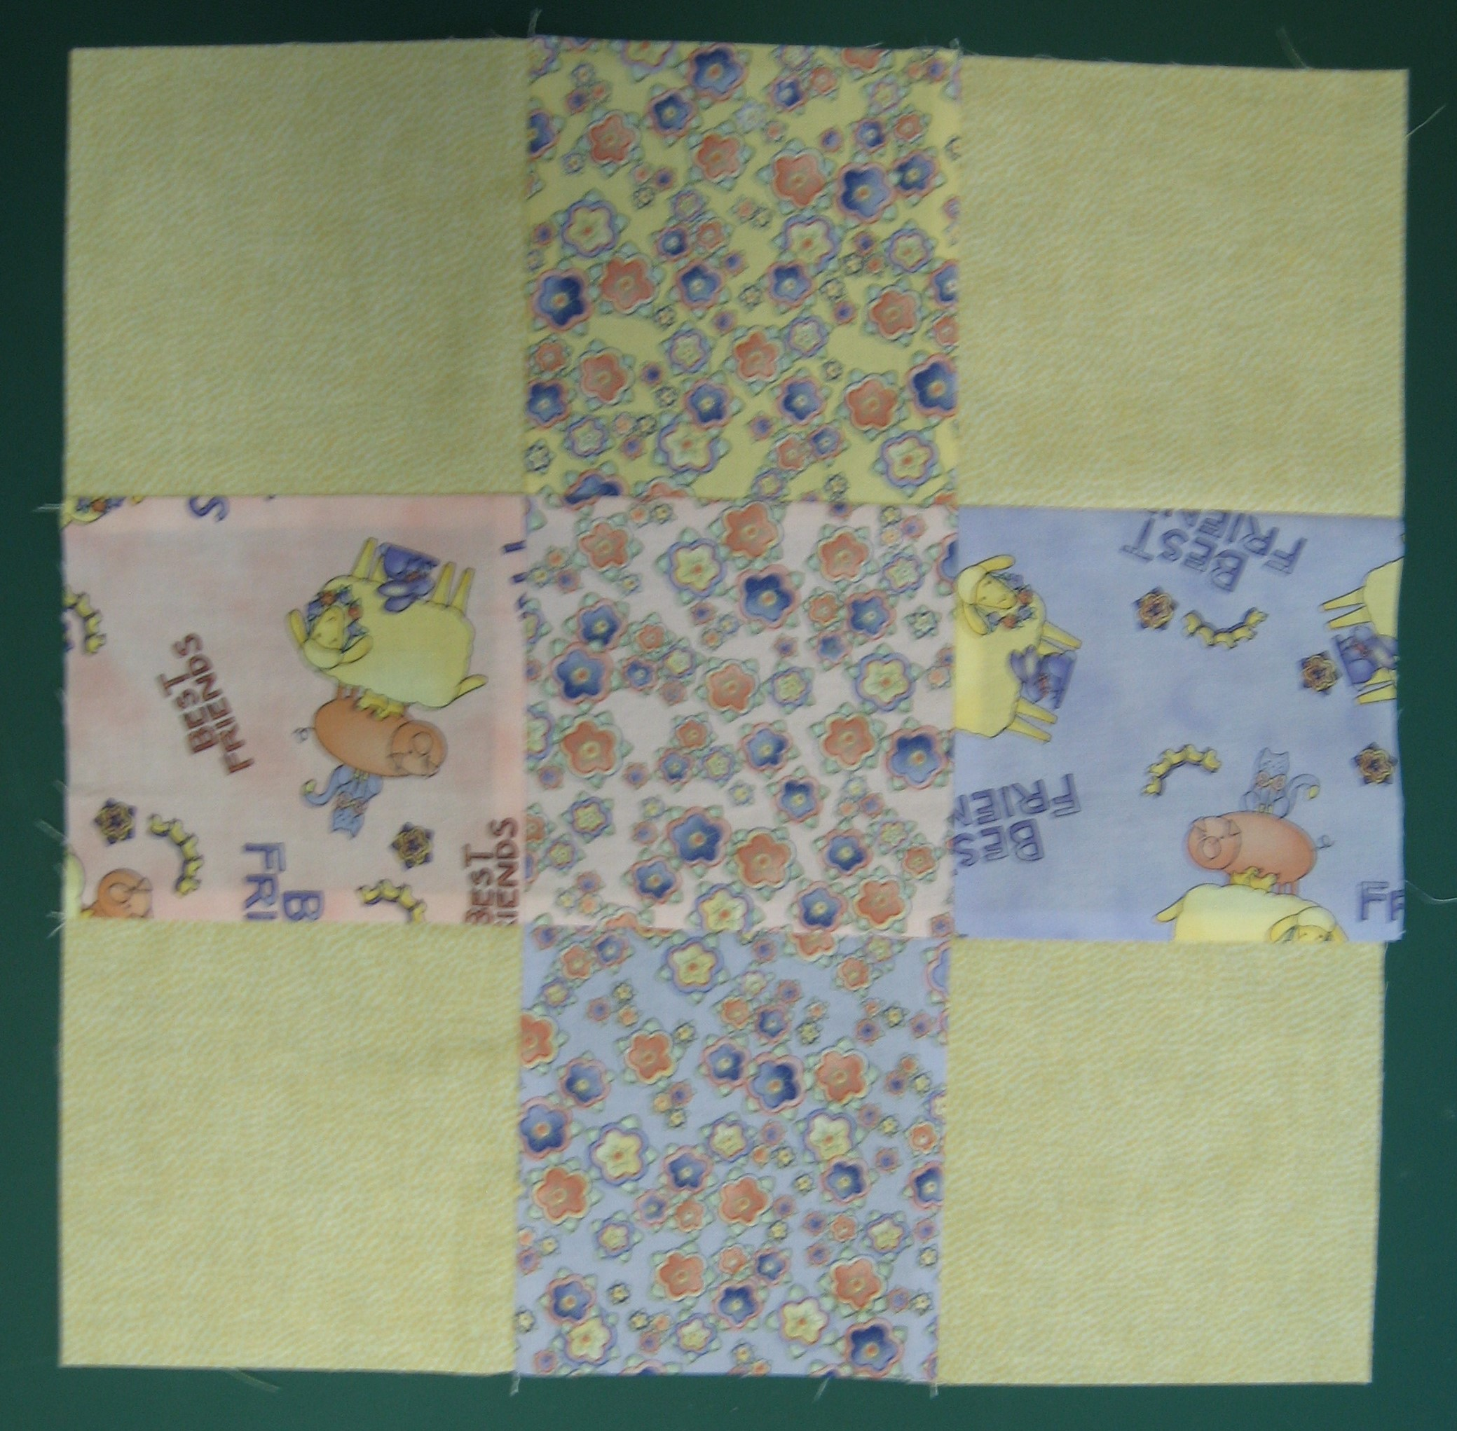

- Assemble 5” Print & Solids Blocks
- Cut in ½ in both directions to make 4 quarters
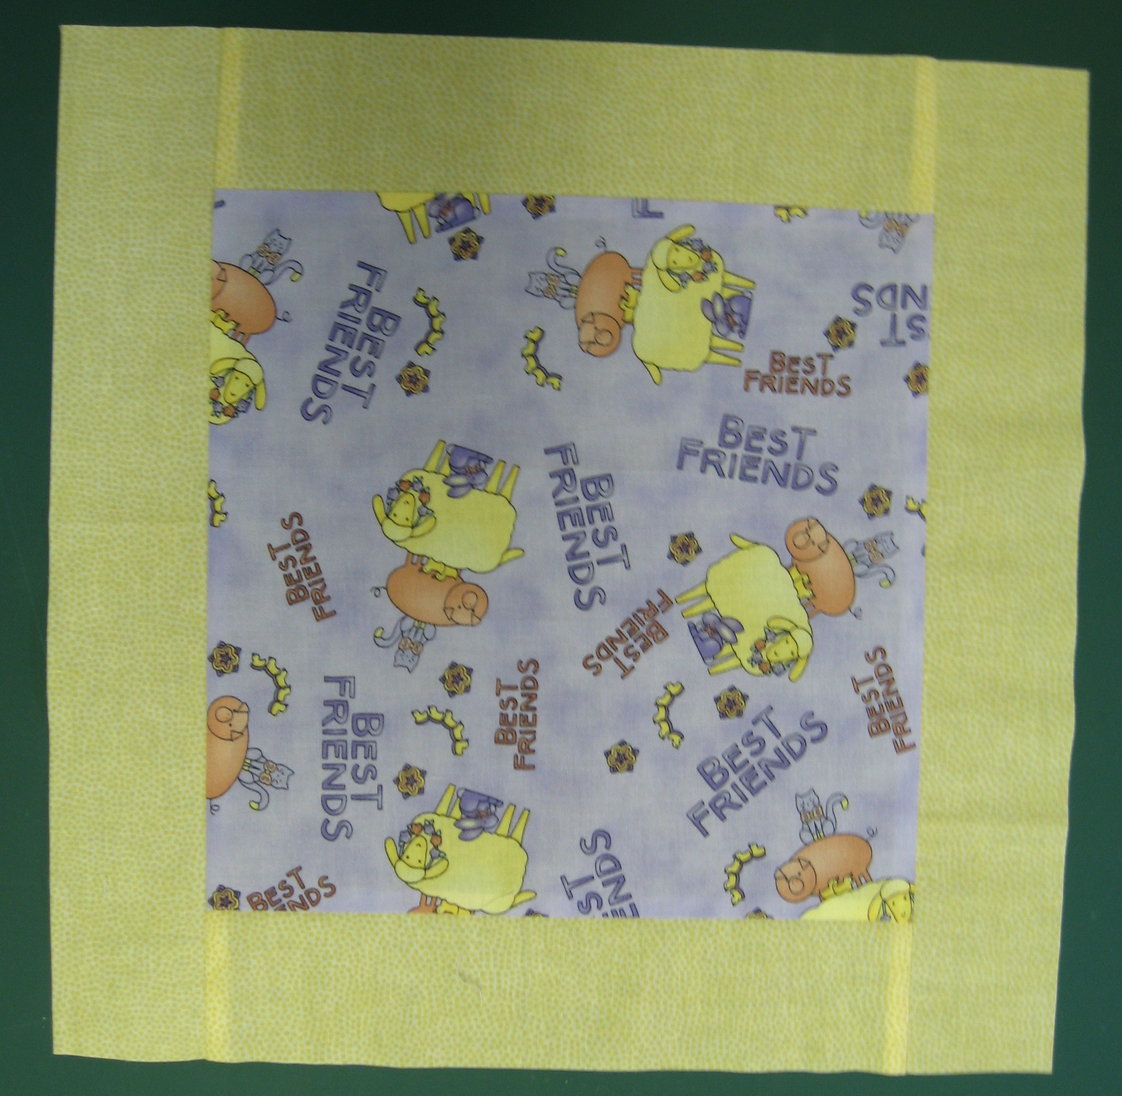
- Flip top left ¼ & bottom right ¼
- Reassemble to form chain link – approx. 13 ½” square
10” Blocks
- Sash sides using 10” strips
- Sash top & bottom using 14” strips
- Trim to approx. 13 ½” or size to match finished split 9 patches
SK Baldry 2019
10”  Block | Split 9 | 10”  Block | Split 9
Split 9 | 10”  Block | Split 9 | 10”  Block
10”  Block | Split 9 | 10”  Block | Split 9
Split 9 | 10”  Block | Split 9 | 10”  Block
10”  Block | Split 9 | 10”  Block | Split 9

