**Quilting Corners Guild**

Christmas 2019 Presentations

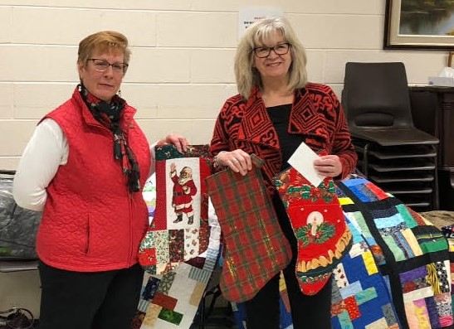

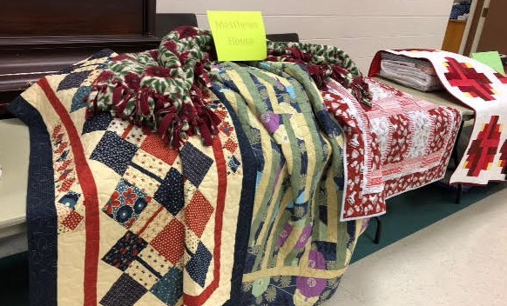

Elizabeth, from Quilts of Valour – Canada, receives 11 Quilts of Comfort created by members of the guild. These quilts will then provide comfort to our injured Canadian Armed Forces members past and present.

Kim, from Matthews House Hospice, receives 16 Quilts of Comfort for their daybeds and one bed-size quilt, to bring warmth and comfort to the wonderful residence.

Sheila, from My Sister’s Place, receives 46 Quilts of Comfort, 108 stockings and 36 Santa Sacks to bring smiles to all.

Presentation display is ready to go with 70 quilts for our annual presentations to MSP, MHH and QoV – Canada. In total QCG has donated 850 quilts to various charities.

