Quilting Corners Guild
Mini Retreats
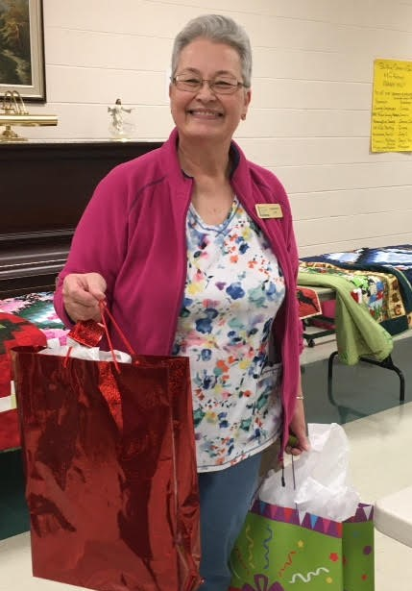
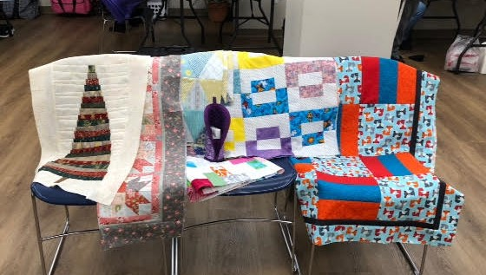

Quilting Corners Guild hosted its first mini retreats for members on November 23rd & 30th. Forty members, current and pending, attended the full day events at Matthews House Hospice using their lovely community rooms. Members enjoyed dedicated sewing time, snacks & treats, goodie bags & prizes, and lots of fun and laughter. Dinner was pre-ordered and delivered from Boston Pizza. Thank you to the organizers – Donna & Cheryl, and all of the volunteers, who made both days run smoothly. Thank you also goes to various sponsors of prizes and MHH for providing the meeting spaces.
Our mini retreat sponsors included:
- All About Sewing Machines
- Alliston Sewing Machine Service
- Country Concessions
- Hummingbird Sewing
- Quilting Accessories
- TrueCut
- Unique
The pics above show some of the projects created and Maryann, one of two winners of our main prizes.

