Quilting Corners Guild
Past President’s Challenge – Viewers’ Choice
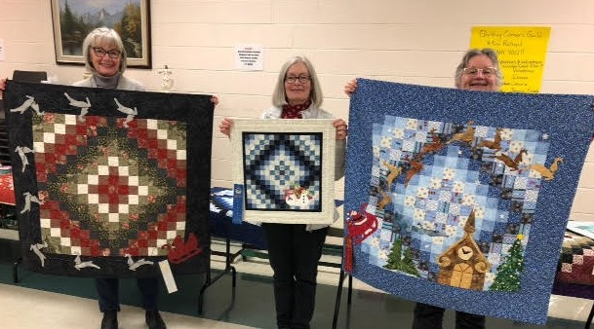

Over the last 6 months 18 members have participated in Cheryl’s Past President’s Challenge. It was a seasonal mystery challenge and the big reveal was on December 3rd. Members selected their ‘choice’ and above is our talented selections, all receiving a ribbon of recognition. Congratulations Ladies!!
3rd Place – Sue S 2nd Place – Donna S 1st Place – Lucie L

