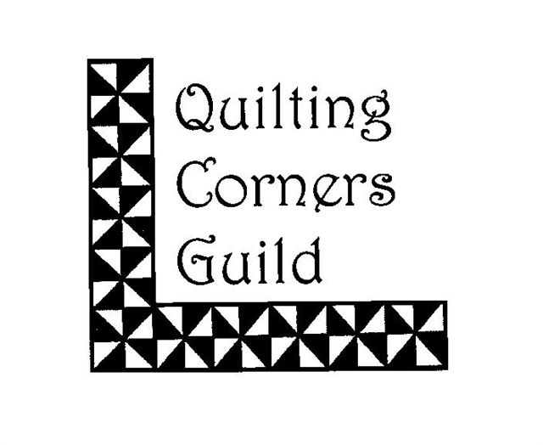
Quilting Corners Guild

April 1, 2020 – March 31, 2021

Membership Form

Please provide in nice, clear print the following information:

NAME: _________________________________________________________________

ADDRESS:_________________________________________________________________

___________________________________________Postal Code ____________

Phone #: ________________________ E-mail___________________________________

The annual membership fee of $35.00 is payable by cash or cheque. Please make cheque payable to Quilting Corners Guild. Thank you.

Paid by: Cheque______ Cash______

Membership fees must be submitted no later than the June Meeting.

Failure to renew annual membership fees as prescribed above may result in loss of membership and put on the bottom of the waiting list.

New Member: __________ Returning Member:__________

Permission to put your name, email and phone number on the members list on the web site:

YES:________ NO:____________

Permission to use photograph of me/my quilt on the website or for other promotions/news:

YES:________ NO:____________

The above information is considered private and confidential and used for guild purposes only.

_______________________________________________ _____________________
Signature Date

