Quilting Corners Guild
Christmas in July 2020 Presentations
On June 29, 2020 Dianne, Cheryl and I made two presentations of almost 150 items to My Sister’s Place and Matthews House Hospice. Given our current gathering restrictions and no July meeting, we took our presentation of quilts to them. Our members have been very, very busy and we were pleased to present an abundance of Quilts of Comfort and various items to each group.
You just can’t keep these quilters down!!!

Quilts sorted and bagged ready to go!
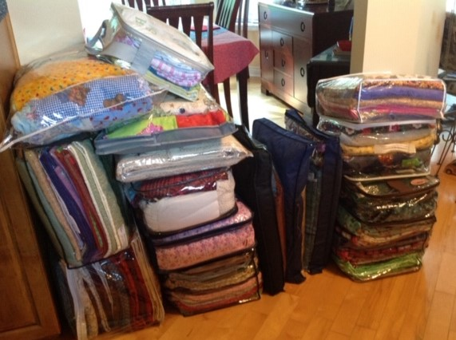

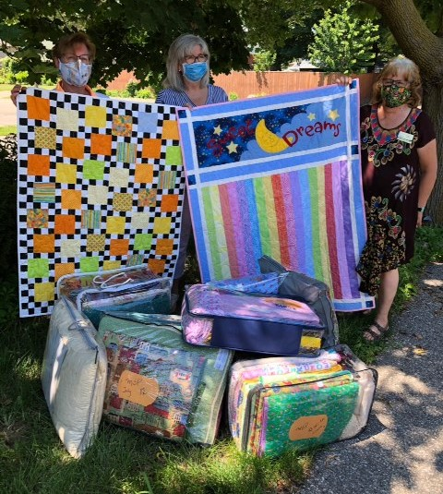

My Sister’s Place
- 7 receiving blankets, 23 bibs
- QoC Kids – 36
- QoC Adult/Youth – 28
- QoC Bed Size – 1
- Seasonal Décor – 5
- Scarves - 5

Senora, Fran & Dianne 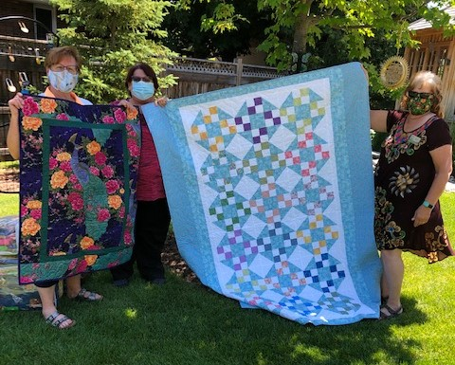
Senora, Sheila & Dianne
Matthews House Hospice
- QoC – Daybed Size – 11
- QoC – Seasonal Daybed – 5
- QoC – Bed Size – 5
- Seasonal Décor – Summer/Fall – 9
- Seasonal Décor – Winter/Christmas - 12

qoC

