Quilting Corners Guild – Community Outreach

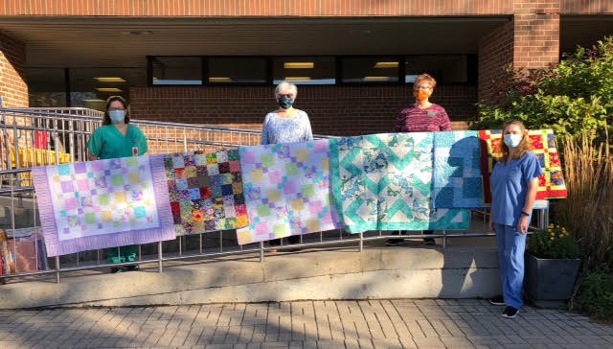
On September 29 Quilting Corners Guild made a presentation of 30 Quilts of Comfort to Simcoe Manor in Beeton, our first donation for their residents. Guild members have been very busy over the last few months creating many quilts for our Community Outreach projects. The quilts are created from donated fabric and through the work of many hands… cutting, piecing, quilting and binding… and the delivery to our community partners. Since 2006 QCG has donated 965 quilts, plus numerous quilted Christmas stockings, smaller quilted items like table runners and seasonal décor and fleece blankets. We are now preparing for our Christmas donations in December.

