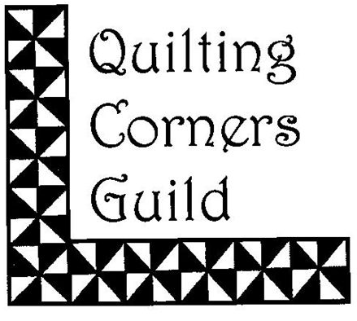
Quilting Corners Guild

April 1, 2023 – March 31, 2024

Membership Form

Please print clearly the following information:

NAME: ___________________________________________________________________

ADDRESS: ________________________________________________________________

___________________________________________Postal Code ____________

Phone #: ________________________ E-mail___________________________________

The annual membership fee of $40.00 is payable by cash or cheque, payable to Quilting Corners Guild. Thank you.

Paid by: Cheque______ Cash______ e-transfer_______ (to Janice.ellingson@gmail.com)

Membership fees must be submitted no later than the June Meeting. Failure to renew annual membership fees as prescribed above may result in loss of membership and put you at the bottom of the waiting list.

New Member: __________ Returning Member: __________

Permission to put your name, email and phone number on the members list on the web site:

YES: ________ NO: ____________

Permission to use photograph of me/my quilt on the website or for other promotions/news:

YES: ________ NO: ____________

The above information is considered private and confidential and used for guild purposes only.

Simply put, our QCG mandate is to bring quilters together to learn, to share skills and to be involved in our community.

Where will you participate? Please select option(s) below.
Quilt show _______________
Executive ________________
Demos __________________
Hospitality Kitchen ________
Community Outreach _____________
Special Events ___________________
Retreats ________________________
Fund raising e.g. Buy and Sell ______
Meeting Set up and Take down ________

_______________________________________________ _____________________
Signature Date

